**WEEK 2: Minimalism**

**Creative**

write a minimalist short-short story (flash fiction) with

NO adjectives

NO adverbs

NO form of the verb TO BE

NO lifeless verbs

NO vague, dull sentences.

Here’s an example:

It started with the spots. Mr. Kilner got the first on his back. Within two days his body was covered in rosettes. The fur appeared the next morning after a long night’s sleep. The claws and fangs were last. By Tuesday, Kilner was a leopard. He left his house on Sycamore and walked on four legs to the beech tree a block over on Cunningham. He climbed the tree, selecting a limb that hung out over the sidewalk. Here came Mrs. Grunhild now, her new antelope horns shining in the noon day sun.

OR

Re-write this piece of overwritten text from *Twilight*.

"You know Bella, Jacob?" Lauren asked—in what I imagined was an insolent tone—from across the fire.

"We've sort of known each other since I was born," he laughed, smiling at me again.

"How nice." She didn't sound like she thought it was nice at all, and her pale, fishy eyes narrowed.

"Bella," she called again, watching my face carefully, "I was just saying to Tyler that it was too bad none of the Cullens could come out today. Didn't anyone think to invite them?" Her expression of concern was unconvincing.

"You mean Dr. Carlisle Cullen's family?" the tall, older boy asked before I could respond, much to Lauren's irritation. He was really closer to a man than a boy, and his voice was very deep.

"Yes, do you know them?" she asked condescendingly, turning halfway toward him.

"The Cullens don't come here," he said in a tone that closed the subject, ignoring her question.

Tyler, trying to win back her attention, asked Lauren's opinion on a CD he held. She was distracted.

I stared at the deep-voiced boy, taken aback, but he was looking away toward the dark forest behind us. He'd said that the Cullens didn't come here, but his tone had implied something more—that they weren't allowed; they were prohibited. His manner left a strange impression on me, and I tried to ignore it without success.

OR

Use one of the following images, or an apocalyptic vision of your own, to write a descriptive passage (50 – 100words) that conveys the desolation of the landscape. Work on showing the desolation and bleakness of the landscape, rather than ‘telling’ how it is.

Optional: (thinking about style) – Alternate between complete sentences and sentence fragments. What effect does this have?

Write from either a first person or a third person limited POV, in which the character is alive and present in the landscape. Try writing in the present tense. Is this version unremittingly bleak? Or will convey a sense of hope in among the bleakness.

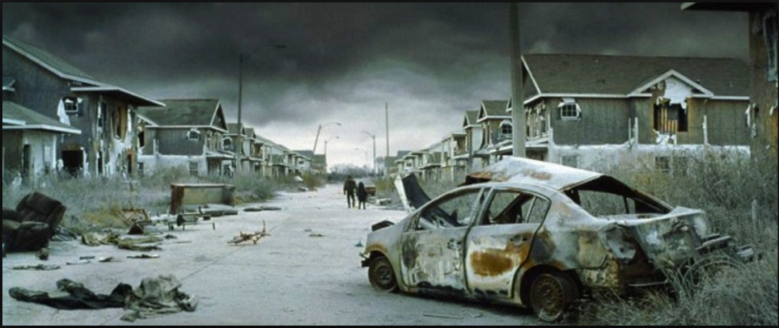

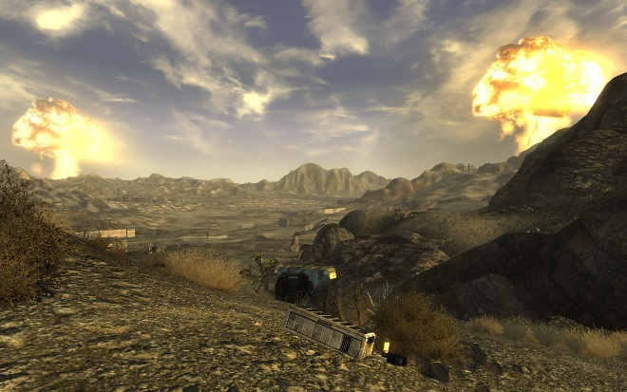

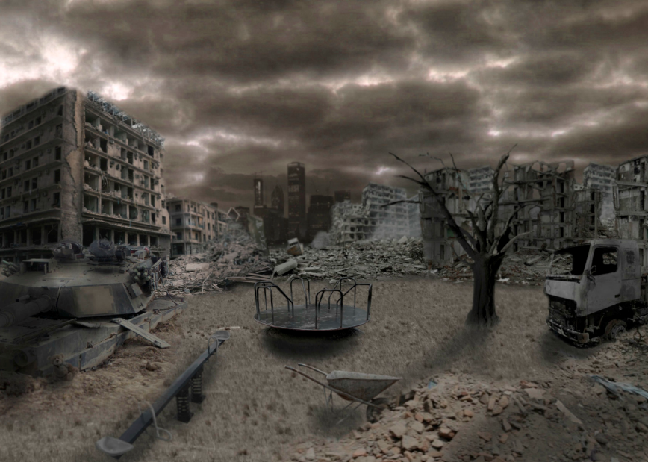

**Critical**

1. Hemingway once said: "No matter how good a phrase [the writer] may have, if he puts it in where it is not absolutely necessary and irreplaceable he is spoiling his work for egotism. Prose is architecture, not interior decoration, and the Baroque is over". Discuss this quote with reference to either *The Road*, *The Old Man and the Sea* (extract) or 'Why Don't You Dance'. Your answer must be supported with textual evidence from the reading, and it must include at least one academic reference.  
   OR
2. Identify and discuss the effects of one minimalist technique as used in two of the assigned minimalist texts. Choose from *The Road*, *The Old Man and the Sea* (extract) and 'Why Don't You Dance'. Your answer must be supported with textual evidence from the readings, and it must include at least one academic reference.

**WEEK 3: Epistolary and SoC**

**Creative**

EITHER

Virginia Woolf: Examine for a moment an ordinary mind on an ordinary day. The mind receives a myriad impressions - trivial, fantastic, evanescent, or engraved with the sharpness of steel. From all sides they come, an incessant shower of innumerable atoms; and as they fall, as they shape themselves into the life of Monday or Tuesday, the accent falls differently from of old.

Write a passage of stream of consciousness, using techniques explored in lectures such as interior monologue, free indirect discourse, non-subordinating style. Aim to show how the mind works. Observe your thinking/ consciousness/ self-consciousness/ awareness of self-consciousness; time travel in past, present, future. Let your reader experience your thoughts and feelings and meanderings, your aliveness…

OR EPISTOLARY

Use the epistolary form to create a piece, using diary, journal, letters, emails, newspaper clippings, power points, or whatever will address the reader (narratee) directly without need for a mediating narrator. Use Monologic, Dialogic or Polylogic forms and make use of dramatic irony to create effect.

**Critical:**

1. Discuss how the use of epistles affects narration in *The Color Purple* (extract). Your answer must be supported with textual evidence from the reading, and it must include at least one academic reference.
2. Discuss the relationship between stream of consciousness and time, as evident in either *To the lighthouse* (extract) or *Portrait of an Artist as a Young Man.* Your answer must be supported with textual evidence from the reading, and it must include at least one academic reference.

**WEEK 4: EF and Transgressive**

**Creative**

Woman must write her self: must write about women and bring women to writing, from which they have been driven away as violently as from their bodies-for the same reasons, by the same law, with the same fatal goal. Woman must put herself into the text-as into the world and into history-by her own movement.” Hélène Cixous, The Laugh of The Medusa

Write a piece of *ecriture feminine*, using techniques gleaned from your readings of Byatt and Attwood, and from Cixous’s injunction to ‘write the body’.

OR

Write a transgressive text, remembering that *transgressive fiction is a genre of literature that focuses on characters who feel confined by the norms and expectations of society and who use unusual and/or illicit ways to break free of those confines. Because they are rebelling against the basic norms of society, protagonists of transgressional fiction may seem mentally ill, anti-social and/or nihilistic. The genre deals extensively with taboo subject matters such as drugs, sex, violence, incest, pedophilia, and crime*. Remember in your writing of this genre that transgressional writing is not gratuitous but serves an aesthetic purpose!

**Critical**

1. In your own words, define the meaning of *Ecriture Feminine* and explain its purpose. Answers that provide direct quotes for their definition and explanation of purpose are not acceptable. Your answer must be supported with textual evidence from either 'Body Art', 'Rape Fantasies' or *The River Ophelia* (extract). It must also include at least one academic reference.
2. Choose either *Lolita* (extract) or *Fight Club* (extract) and discuss how it is 'transgressive' and why there is value in its transgression. Your answer must be supported with textual evidence from the reading, and it must include at least one academic reference.

**WEEK 5: Metafiction**

**Creative**

Authors of metafiction often violate narrative levels by intruding to comment on the writing, involving themselves with fictional characters, directly addressing the reader, or employing other techniques that reveal the work's fictional state. Using the week 5 readings as a guide to these techniques, write a piece of metafictional flash fiction.

**Critical**

1. Describe how metafiction is used in any one of the readings from week 5. What effect does the use of metafiction have on the narrative, and why might the author have chosen to use metafiction in this way?

**WEEK 6: Postmodernism**

**Creative**

Write a post modern piece, using some of the devices of pomo, such as irony, playfulness, black humour, parody of older forms, pastiche, intertextuality/referentiality, juxtaposition of clashing genres/images, exposure of mechanisms of production. Or try experimenting / playing with one of these:

Write backwards

Use experimental forms

Play with voice

Be ergodic

Be polyphonic

**Critical**

1. What is postmodernist writing? Answer this question with reference to postmodern narrative techniques used in *Slaughterhouse 5.*Your answer must be supported with textual evidence from the reading, and it must include at least one academic reference.

**WEEK 7: Magic Realism**

**Creative**

Write a Magic Realist piece:

Establish the familiar, then lift the veil.

Make your real world REAL.

Push yourself over the edge.

Suspend disbelief, and believe what you write.

Don’t be afraid to leave the door open.

Make sure that you are writing Magic Realism and NOT fantasy

**Critical**

1. How is Magic Realism different from fantasy? Choose one of the week 7 set texts and discuss what elements in this story locates it as a magical REAList text.

**WEEK 8: Writing Australia**

**Creative**

Write a piece that is characteristically ‘Australian’ either in setting, voice, character, theme or plot.

Or

A frame story (also known as a frame tale or frame narrative) is a literary device that sets the stage for a set of narratives embedded within its structure. Following Bail’s use of the frame tale, devise a frame tale of your own that points to/ contains/ embeds a larger set of stories within it.

**Critical**

1. Choose one embedded tale from within *Eucalyptus* and discuss its relationship with the frame story. Your answer must be supported with textual evidence from the reading, and it must include at least one academic reference.

**WEEK 11: Postcolonialism**

**Creative**

Nadine Gordimer said once that ‘Art is on the side of the oppressed’. Write a post-colonial piece in which contextualize your scene in a post-colonial framework.

Or

After closely examining Coetzee’s narrative voice/style in *Disgrace*, write a piece in close third person present with free indirect discourse (which does not use ‘thought’ verbs like ‘think’, ‘know’, ‘realise’).

**Critical**

1. What is postcolonial writing? Answer this question with reference to postcolonial narrative techniques used in *Disgrace*. Your answer must be supported with textual evidence from the reading, and it must include at least one academic reference.